EXPERIMENT-3
NAME:ASHIKA R ROLL NO:240701054

1.COMMAND LINE INTERFACE:

PYTHON CODE:

import os
import sys

if len(sys.argv) < 2:
print("Usage: python delete.py <filename>")
sys.exit()

file_name = sys.argv[1]

if os.path.exists(file_name):
os.remove(file_name)
print(f"{file_name} deleted successfully!")
else:
print("File not found!")

OUTPUT:

2.GRAPHICAL USER INTERFACE:

PYTHON CODE:
import tkinter as tk
from tkinter import messagebox
import os

def delete_file():
file_name = filename_entry.get().strip()

if not file_name:
messagebox.showwarning("Warning", "Please enter the filename!")
return

if not os.path.exists(file_name):
messagebox.showerror("Error", f"File '{file_name}' not found.")
return

confirm = messagebox.askyesno("Confirm Delete", f"Are you sure you want to delete '{file_name}'?")

if confirm:
try:
os.remove(file_name)
messagebox.showinfo("Success", "File deleted successfully!")
filename_entry.delete(0, tk.END)

except Exception as e:
messagebox.showerror("Error", f"An error occurred: {e}")

root = tk.Tk()
root.title("File Deleter")

tk.Label(root, text="Enter Filename to Delete").pack()

filename_entry = tk.Entry(root, width=30)
filename_entry.pack()

tk.Button(root, text="Delete File", command=delete_file).pack()

root.mainloop()

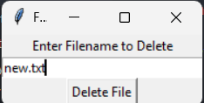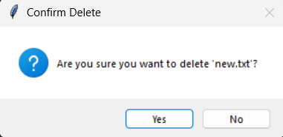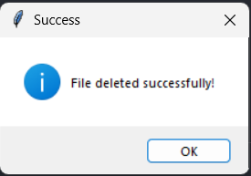

3.VOICE USER INTERFACE:
PYTHON CODE:
import speech_recognition as sr
import os

def delete_file_from_voice_command(command):
words = command.lower().split()

if "delete" in words:
file_name = words[1] + ".txt"

if not os.path.exists(file_name):
print(f"❌ File '{file_name}' not found!")
return

os.remove(file_name)
print(f"✅ File '{file_name}' deleted successfully!")

else:
print("❌ Say: Delete filename")

def listen_for_command():
recognizer = sr.Recognizer()

with sr.Microphone() as source:
print("\n🎤 Speak now...")
print("👉 Example: Delete test\n")

recognizer.adjust_for_ambient_noise(source)

try:
audio = recognizer.listen(source, timeout=10, phrase_time_limit=8)
except sr.WaitTimeoutError:
print("❌ No voice detected!")
return

try:
command = recognizer.recognize_google(audio)
print("🎙️ You said:", command)

delete_file_from_voice_command(command)

except sr.UnknownValueError:
print("❌ Could not understand voice.")

except sr.RequestError:
print("⚠️ Internet problem.")

if __name__ == "__main__":
listen_for_command()
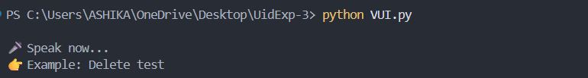

4.USER SATISFACTION COMPARISON:
PYTHON CODE:
def survey():
print("Rate your satisfaction with the following interfaces (1-5):")

try:
cli_satisfaction = int(input("CLI (1-5): "))
gui_satisfaction = int(input("GUI (1-5): "))
vui_satisfaction = int(input("VUI (1-5): "))

if not (1 <= cli_satisfaction <= 5 and
1 <= gui_satisfaction <= 5 and
1 <= vui_satisfaction <= 5):
print("Please enter ratings between 1 and 5 only.")
return

print("\nYour satisfaction ratings:")
print("CLI:", cli_satisfaction)
print("GUI:", gui_satisfaction)
print("VUI:", vui_satisfaction)

avg_satisfaction = (cli_satisfaction + gui_satisfaction + vui_satisfaction) / 3
print("\nAverage Satisfaction Score:", round(avg_satisfaction, 2))

except ValueError:
print("Invalid input! Please enter numbers between 1 and 5.")

if __name__ == "__main__":
survey()

